Shared Memories of Forgotten People
Simon’s Town 24 September 2017

Kenneth M Alexander

Shared Memories of Forgotten People
Shared Memories of Forgotten People
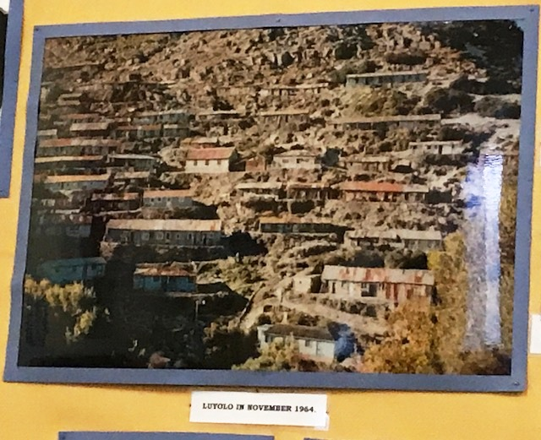
Psalm 121

I lift up my eyes to the hills-- where does my help come from?

My help comes from the LORD, the Maker of heaven and earth.

He will not let your foot slip-- he who watches over you will not slumber;
indeed, he who watches over Israel will neither slumber nor sleep.

The LORD watches over you-- the LORD is your shade at your right hand;
the sun will not harm you by day, nor the moon by night.

The LORD will keep you from all harm-- he will watch over your life;
the LORD will watch over your coming and going both now and forevermore.

Shared Memories of Forgotten People
Simons Town 24 September 2017

1. Heritage Day 2017

Cape Town, South Africa, the land of sunshine, rugby, sunny skies and braais. Yes, we are a crazy nation always ready for a “tjop and a dop”. A “tjop” not just fried in a pan or in an oven but over an open fire either at home, alongside one of our many lakes or at a local designated recreation area in a forest on the slopes of Table Mountain. The green or blue canvass deck chairs are never forgotten as it rarely leaves the boot space of one’s vehicle.
How important can a braai be you may ask? Well to cut a long story short it has captured the day, 24 September set aside to celebrate our multi cultured, rainbow coloured, fair aisle jersey Heritage. One pearl, two plain, drop one stitch, pick up a couple, over arm, under arm repeat the above for the next ten rows and so forth and so on, only to be pulled out two days later and then it all starts over again. Yes, we are colourful intricately woven people. However, braai-ing to us not only competes with our past but it totally overpowers it. It reminds one of the 57-0 bashing the Springboks received at the hands of the All Blacks only 7 days ago. Yes, our heritage gets a zero junk rating. Surely this cannot be true after the many years of slavery, hardship, suffering, apartheid, forced removals and even the present “intensive care ward” we find ourselves in, in 2017.
Could this be one massive cover up? Could this be likened to the “cloth of cloud” over Table Mountain?
Sunday morning: 24 September 2017. The weatherman says that we can expect a chilly day with temperatures reaching a maximum of 17degrees. No one really cares because no one ever cares.
Off we go on our merry old way to Simon’s Town. Muizenberg, St James, Kalk Bay, Sunny Cove, Glencairn and eventually, Simon’s Town. The train line separates us from the thin strip of rocks and beach separating the tracks from the sea. There is no barrier separating us from the smell of the sea though. Just before we enter Simon’s Town we past Dido Valley cemetery on the left. If only those laid to rest there could rise up and tell us their forgotten stories. We all know that it was lost on the day that they were wheeled in on the wooden cart now displayed in the museum to be stared at by visitors. Visitors who really do not care.
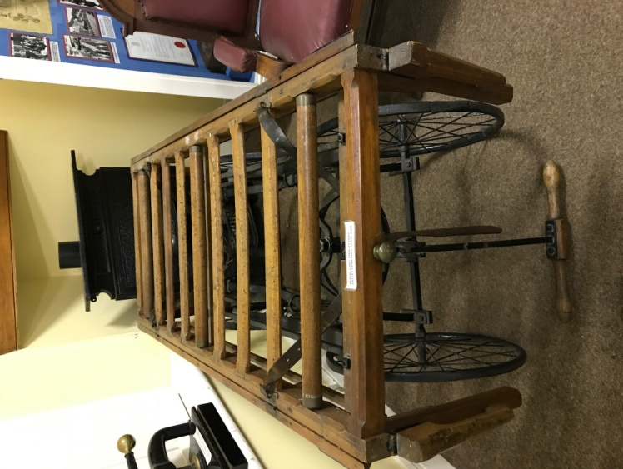
That last ride on the wooden cart to Dido Valley

And then we arrive at the Museum just before the clock strikes 9 bells. One, two, three, four and so on...........Early for once we have the time to walk from room to room in an attempt to absorb the vast information and exhibits displayed on walls and in glass fronted show cases. It is far too much information to possibly grasp in any limited time. Far too much for an unlimited time, to be honest. How can you decide what to read or what not to read? Each and every laminated picture tells a story of a God given valuable life of many volumes. A story of someone’s childhood, youth, life, background, hopes and dreams. Dreams absorbed and destroyed by life being born at the wrong time. Someone just as important like you who you will never ever meet. But who really knows and who really cares? You just may meet one of his or her descendants at a braai one day on Heritage Day.
The museum is filled with a vast array of all sorts of information and displays. The references of which family lived in which road and in which area was of extreme interest to me. The areas of Simons Town, Dido Valley, Red Hill, Luyolo, Noordhoek and Sunnydale repeated itself from one picture to another. Quarry Road, Goede Gift, Rectory Lane, Thomas Street, Hospital Lane, Smith Lane and the Waterfall Road Flats jumped out at me, and there were many more which slipped my memory. Suddenly my eyes were opened. District 6 in central Cape Town was not the only area mutilated and raped from the people of colour as the world has been brainwashed to believe. Even us the braai hungry people have been brain washed and we remain filthy and silent in our state of ignorance. We try and bury the past in shallow graves. The slightest change in our environment brings the past back to life.

2. The Procession of Remembrance

When “The Ocean View Bikers” arrived you know that something is about to happen and they were there on the powerful machines just like in the movies.
They were dressed in the traditional black leather biker uniform or Jean jackets embroidered with various patches. The patches, or their "colors" as the bikers call it, speak a language of their own. These bikers came with a purpose and not an attitude. Their bikes came to tell a story. If only the people would listen.
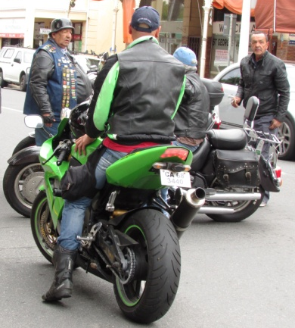
And the Church brigade marching band with instruments such as big drums, bugles, cymbals and flutes were also there lead by tye “voorloper” twirling his baton. The brass instrument glistened from time to time up as the sun battled to penetrate the clouds of the chilly “politically correct” overcast Spring morning in the southern most part of Cape Town.

The day’s proceedings followed a prayer by Padre Jerry Galant after a briefing by the Rev Peter Storey.

Why Peter Storey? His words below should settle that.
“Whites sucked from our country what we needed for our lifestyle, then the highest standard of living in the world. We left the majority of our citizens, who were black and whom we hardly cared to know, with no hope for a better life. We used their labour and resources, but preferred them to be invisible.”
White South Africans knew little about the lives—let alone the real names—of the blacks who cleaned their homes and watched their children.
“They knew everything about us, every intimate detail, including the colour of our undershorts.”
An extract from “Fig Tree” 2005

The procession started from the courtyard in front the Museum and St Francis of Assissi Church and proceeded down...toward Jubilee Square lead by the bikers and the brigade bands. Old and young, male and female marched side by side. The older folk grabbed the opportunity to share and reminisce with anyone. It gave a new meaning to my cup runneth over.

- “That is the pier that my brother dived off. Why is that man standing there?”
- “That is where we lived”
- “That is where I went to school”
- “That is the church where my sisters and I cleaned the brassware”
- “That is where the fish monger sold his fish”
- “That is the Lord Nelson Hotel”.
- “It looks so different now”

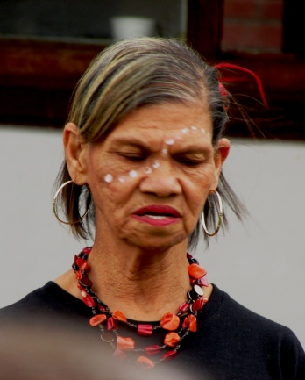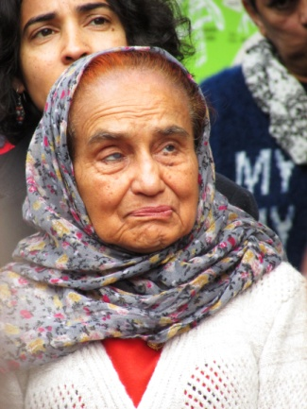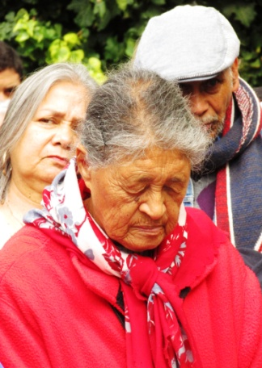
One could sense the pain, anger, disappointment in the tone of the people confirmed by the sadness portrayed on their faces. Some tried to cover it up with a smile and a hug when they recognised a face from the past.
The posters however were painted and final, speaking a language of it’s own. A universal language with only one common meaning.
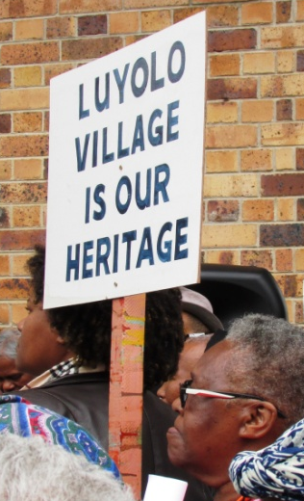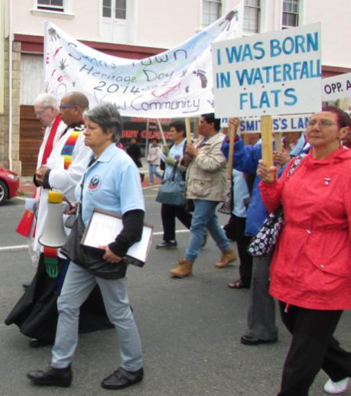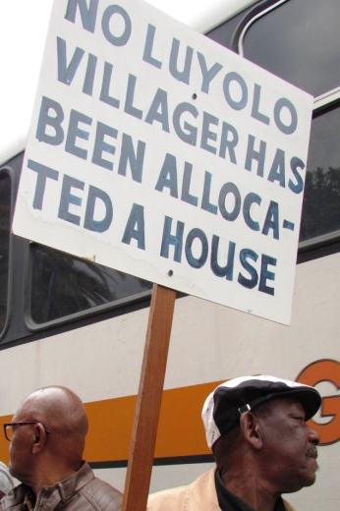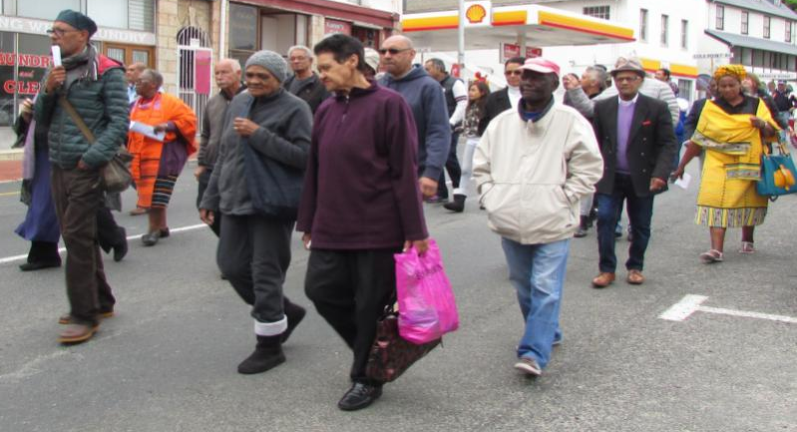

The message on the hand held boards read:
- “We are the forgotten people”
- “Luyolo Village is our Heritage”
- “Dido Valley belongs to us and our offspring”
- “I was born on Waterfall Flats”
- “Red Hill is our Heritage”
- “No Luyolo Villager has been allocated a house”
- “Back to Simons Town”
Surely this is a very clear message that all is not over. The people have murmured and now it is written.

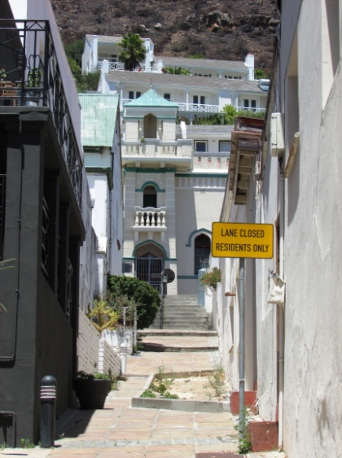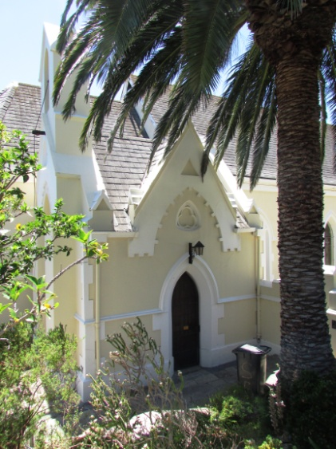
3. The Monument to those who suffered under the Group Area Act

Wreaths were laid at the foot of the monument by representatives of Simons Town, Red Hill, Luyolo Village, Noord Hoek and Sunnydale. The sounding of the last post was performed by the retired Commander Mike Oldham followed by the South African National Anthem performed by the Izivunguvungu MSC Youth Band while life just past on unnoticed to the now local inhabitants and tourist passer bys.
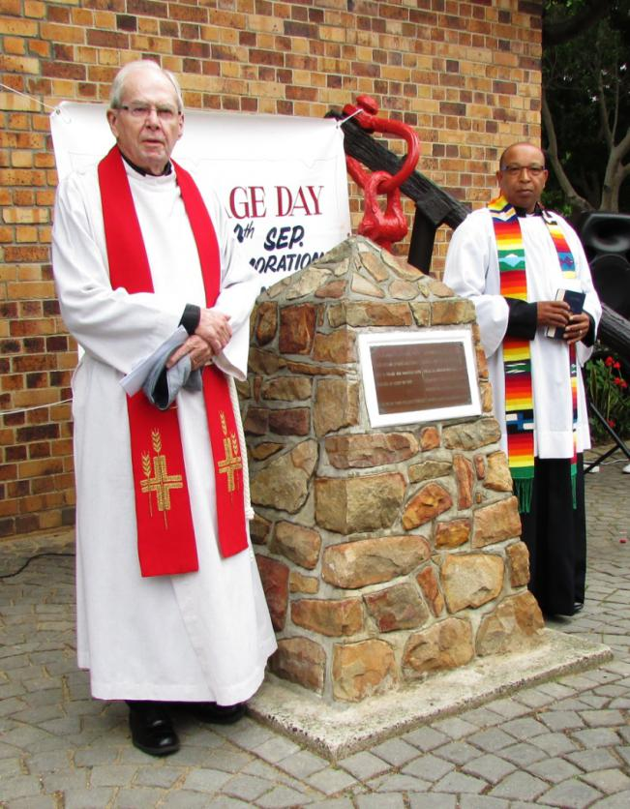

50 years ago 7,500 people of colour were moved from the area and many stood by.
Today, 50 years later the very same area has 6,500 people

The 7,500 were made up of Fishermen, railroad workers, dockyard workers, seamstresses, tailors, artisans, labourers, vegetable traders, fathers and mothers and children.

“Is it nothing to you, all you who pass by?

Rev Peter Storey

Lamentations 1 (NIV)
1 How deserted lies the city,
once so full of people!
How like a widow is she,
who once was great among the nations!
She who was queen among the provinces
has now become a slave.
² Bitterly she weeps at night,
tears are on her cheeks.
Among all her lovers
there is no one to comfort her.
All her friends have betrayed her;
they have become her enemies.
³ After affliction and harsh labor,
Judah has gone into exile.
She dwells among the nations;
she finds no resting place.
All who pursue her have overtaken her
in the midst of her distress.
¹¹ All her people groan
as they search for bread;
they barter their treasures for food
to keep themselves alive.
“Look, Lord, and consider,
for I am despised.”
¹² “Is it nothing to you, all you who pass by?
Look around and see.
Is any suffering like my suffering
that was inflicted on me,
that the Lord brought on me
in the day of his fierce anger?

Interfaith service of Remembrance
South African Navy Sports Field

Candles of hope were lit resembling light and of hope for the future. Prayers were said, various speakers reflected on the “good old days” in Simons Town and adjoining villages and dances were performed while doughnuts, tea and coffee were served.
Many shared some very funny stories and others which brought tears to one’s eyes. Below find some.
The funnies:
- School Children getting Cod Liver Oil in the morning whether they liked it or not........and to make matters worse all from the very SAME spoon
- Watching movies from a projector in the “front room” in reverse.
- Running through Dido Valley Cemetery after dark as a dare
- The vegetable seller having a drink of red wine out of a cup in the “lokasie” (village) on the way home eventually not being able to ride the horse and cart home safely.
- “Vrietangs” changes to “Sierangs” once a horse pee’s on it.
- For some unknown reason one man repeated sub standard B in 1964,1965 & 1966
- How do you write “tamatie smoor” in English?

Those that opened wounds:
- The sad procession which followed bakkies moving families and furniture and no one could do anything.
- In Gugulethu there were no schools, no clinics, no shops and no sea to catch fish from. There was nothing.
- Seamen returning to empty homes.
- Being moved from a peaceful neighbourhood to one where we live to survive.
- Being treated like sub humans we were taught to hate ourselves
- We were left to mourn without support
- No one remembered us. Everyone were too focused on District 6
The list can go on and on and on.
We are now told to move on, to forgive and forget. One of the speaker’s was willing to do so, but conditionally. He proposed having two boxes and to dig two holes side by side large enough to bury those boxes nice and deep.
In one box he will bury all his pain, hurt, despair, hopelessness, frustration, heritage, financial loss, 3rd storey flat in Ocean View or two roomed home with leaking roof in Gugulethu, Metro Rail train ticket, job as a cleaner etc and that the previously advantaged white person do likewise with his arrogance, lack of empathy and sympathy, financial gain, privileges, hope, happiness, own business, home on the mountainside of Simons Town and holiday home in Knysna, his 4x4 and BMW motorbike.
We then bury both boxes and walk away equal.
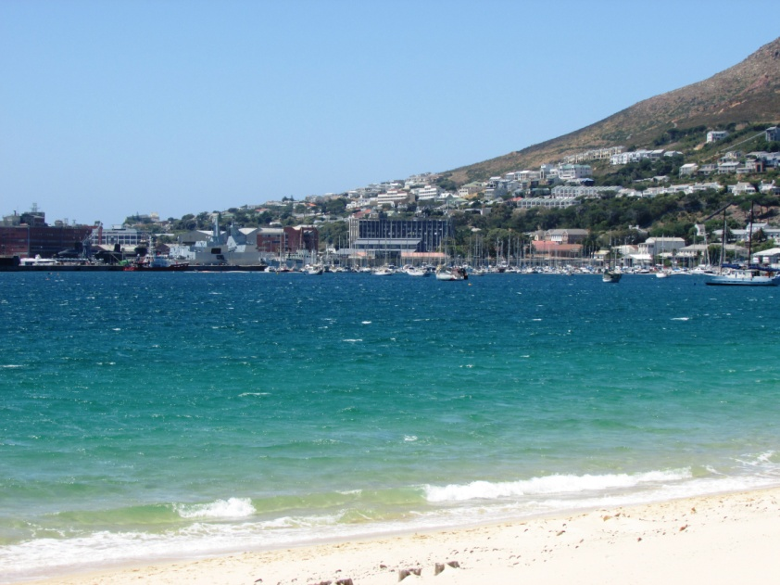
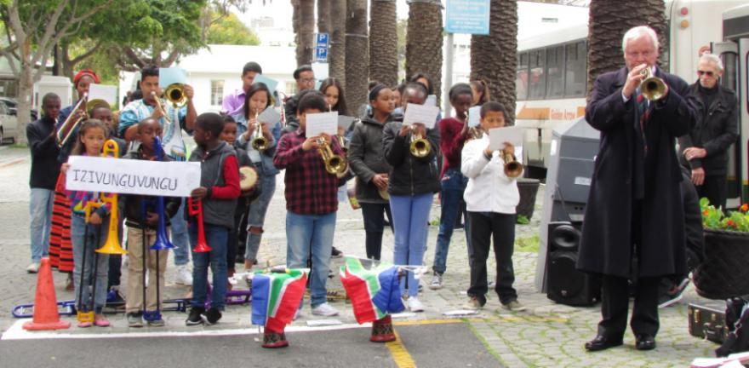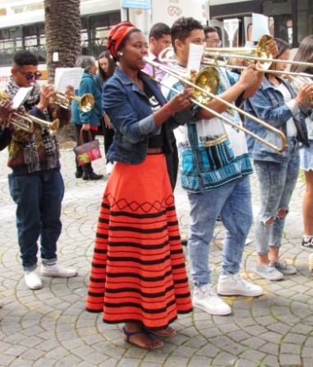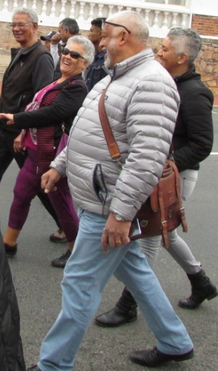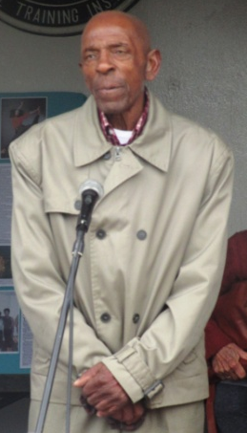

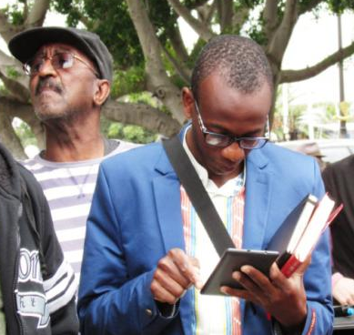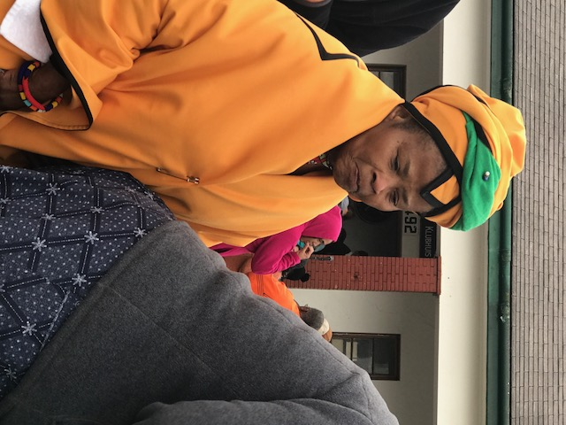

In an article Young wrote for the Cape Argus in 1998, Zainab Davidson described how her father “used to sit on the stoep and swear:
‘I will not budge... either they’ll have to push me out or carry me out in a wheelbarrow.’”
Young wrote: “The Nationalists won the contest but tragically by default when old man Amlay died a broken man, uncertain what the future held for his wife and their nine children. Mrs Davidson’s brother, Agmat, had the same dogged determination as her father and he refused to move.
“By 1975, he was the only ‘affected’ resident still in Simon’s Town. One morning, however, a navy truck pulled up and loaded him up, along with whatever possessions there was space for, and carted him off to a tiny council house in Ocean View, which was to be his new home.”
An extract of article written by Joline Young for the Cape Argus in 1998.

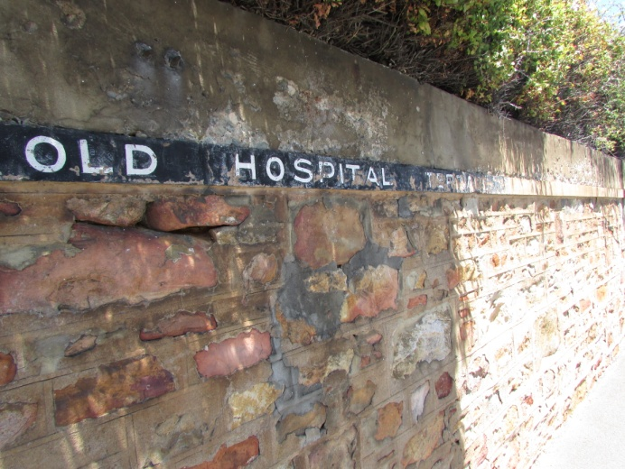

The Kroomen
Brought to Simon’s Town as contract workers, they performed several arduous tasks such as mooring, clearing coal from lighters and watering and coaling of ships. On board they fulfilled various job descriptions, as stewards, cooks, carpenters-mates and deck-hands.
As an aside, joining the Navy also meant a new identity for indigenous Kroo people, in that their African names were replaced with names given to them by the Navy. Some of these names were overtly British, and others were downright degrading such as Black Whale, Jim Crow, Bottle of Beer, Tom Cockroach and Dick Deadeye.
The Navy tried to insulate the Kroomen from the local community. The local people, whom the Kroomen were to avoid, were people whose ancestors were indigenous San and Khoi people or people whose ancestors were enslaved.
The Kroomen attracted the interest of some of the local women, and vice versa. This resulted in a number of liaisons taking place, some resulting in marriage. These men now adopted Simon’s Town as their new home and did not wish to return to Sierra Leone when their contracts expired. A Krooman who married a local woman was Jack Savage, whose Certificate of Service in the Royal Navy shows that he first entered their service on the Penelope on 1 October 1893. He and his wife Sabinea lived in Davis Cottage Simon’s Town. Thrice decorated by the Navy; his last medal was the British War Medal, which he received on 31 August 1925.
Jack Savage’s last surviving son, Mr Peter James Savage was moved to Ocean View. He recalls a happy childhood in Simon’s Town. Certain of his mannerisms, especially his very entertaining and amusing way of questioning me with riddles, is a mannerism that I have been told by another Simon’s Town resident, was very typical of the Kroomen.

The Dutch and the Khoikhoi
Jan van Riebeeck, a representative of the VOC, established a station at the Cape of Good Hope, the southern tip of Africa, in 1652. The intention was to provide a post where traders could restock their ships with fresh water and food on the long and arduous journey to East Asia. The VOC brought soldiers, slaves and settlers to the Cape from the Netherlands and the East and eventually the station became a conventional colony when Europeans started to settle there.
Who are the Khoikhoi?
The Khoikhoi are a race of people of Southern Africa, of short stature and a dark yellowish-brown complexion, who formerly occupied the region near the Cape of Good Hope and are now almost extinct.
By 1656 the first conflict between the Dutch and local Khoi erupted. This occurred as a result of the appropriation of land by Dutch farmers. The Khoikhoi saw the Dutch as competition for available grazing and as invaders who were curbing their freedom of movement while the Europeans regarded the Khoikhoi to be inferior and a ready labour pool. The Cape soon became a colonial project and as a result of the importing of slaves the economy developed as slave-based. This state of affairs resulted in a social system of master and servant becoming firmly entrenched with the Europeans as masters while indigenous people were delegated to slaves and servants.

The Slaves
The Dutch imported slaves into the Cape from Gambia, Angola, India, Zanzibar, Nigeria, Mozambique, Madagascar, Sri Lanka, Indonesia, Jakarta and the Spice Islands. The slaves became part of the Simon’s Town population.

The St Helenians
Large groups of settlers from St Helena came to the Cape at various times during the 1800’s and early 1900’s. Many of the islanders settled in Simon’s Town.

Simon’s Town Dockyard
A small dockyard facility was first established in Simon's Town by the Dutch East India Company in 1743.This was taken over by the British Royal Navy (RN) in the 1790s, under whom the facility was further developed over the following century and a half. A pair of handsome stone storehouses dating from the 1740s stand on the seafront where they were built by the Dutch East India Company, marking the initial location of the Yard. Immediately adjacent is the earliest Royal Naval building on the site: a combined mast-house, boathouse and sail loft; dating from 1815, it now serves as the South African Naval Museum.
Over the next few decades, the site was developed gradually, with steam engineering and coaling facilities being added mid-century. In 1885, the government of the Cape Colony transferred the assets of the Simon's Bay Dock and Patent Slip Company to the British Admiralty. By the close of the century, however, it became clear that more space would be needed to accommodate the requirements of a modern Navy. In 1898, a large site was acquired to the east of the original Yard for a dockyard extension. Sir John Jackson and Co Ltd. were chosen to do the work.
Construction began in 1900. The new harbour encompassed an area of 11 hectares, with a breakwater of 914 metres in length. It also contained a drydock 240 metres long and 29 metres wide, with a sizeable steam factory constructed alongside. The drydock was named the Selborne Graving Dock after the Earl of Selborne, the High Commissioner of the Cape. Work on the Simon's Town dockyard was completed in 1910.
The naval base was handed over to South Africa in 1957 under the Simonstown Agreement.

Editorial note:
Here is a sample of his artwork on Simon’s Town
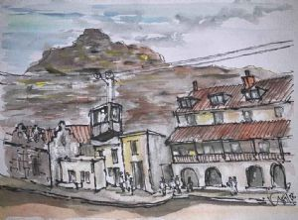
This is the old cable car in Simon’s Town
He also runs at Art centre/studio at 84 Thornton rd, Athlone. Equiries : Deidre: ph 0836437887.
The artwork of Kenneth Alexander can be found at:
southafricanartists.com/artists/kenneth-alexander-6666

