Name: Florence Mkhize
Date of Death: 1999
Florence Mkhize was an active member and leader in some of the most prominent organizations that worked to end apartheid in South Africa, including the Federation of South African Wome​n (FEDSAW), the African National Congres​s (ANC), the ​Women's League of the AN​C,​ the Sout​h African Communist Party (SACP), and the ​United Democratic Fron​t (UDF). Despite several​ banning orders and imprisonment, she served her community and nation from her teenage years until her death and worked tirelessly to organize protests and push South Africa towards democracy.
Florence Mkhize was born on 20 November 1936, in Umlazi. Her mother, Ernestine, was a schoolteacher and her father, William Mkhize, was a preacher. He died in 1939, and her mother remarried to Jonathan Mkhize. Florence had siblings from both fathers, and her brother passed away in 1948. After completing basic schooling at a Roman Catholic boarding school in Umlazi, she followed in her aunt's footsteps and became a seamstress. Her aunt, Bertha Mkhize, encouraged her political involvement and inspired her early activism. She joined in earnest when her stepfather was arrested because he did not have a pass, and this issue remained close to her heart for the rest of her life. In the 1950s she married Amos Mswane, and they had four children.
She was 16 when she joined the Defiance Campaig​n,​ which protested the passing of unjust laws. Due to her participation, she was banned for the first time in 1952. However, she continued to serve the cause, and used the sewing factory at which she worked as a base for communications. In 1954, Mkhize founded the Federation of South African Women (FEDSAW) along with several other notable people, and went on to become the Natal provincial secretary of this organization. FEDSAW was a non-racial organization that encouraged members of the African National Congress Women's League to join their cause, creating connections between the two groups. She joined the ANC in 1955 and participated in the first demonstration against Bantu Education, which would become a lifelong effort of hers. That same year, police stopped her bus on its way to Kliptown where she planned to attend the Congress of the Peopl​e and help​ in the creation of the Freedom Charte​r. However, her bus was forced to turn around and go back​ to Natal. On 9 August 1956 she was involved in a demonstration against the extension of pass laws to women as the Organizer of the Women's League of the ANC in Natal.¹⁰ this demonstration was organized primarily by Lilian Ngoyi and Helen Joseph through the Federation of South African Women. Mkhize used the sewing factory where she worked as a meeting place. A group of approximately 200 protesters, including Mkhize, left Durban by bus the day before the demonstration. Upon reaching Pretoria, they joined the rest of the women to create a group of 2,000 women. Mkhize became a target of the government due to her substantial participation in protests.
In 1957 Mkhize continued to work towards equality, and despite having an appointment with the chief Native Commissioner of Natal to discuss pass laws, he refused to speak with her.
She was arrested for the first time along with 622 other women after protesting passbooks
outside of his office in Harrismith. Outside of such protests, she led the Potato Boycot​t and the​United Tobacco Company boycott in 1959 as a member of the South African Communist Party. Her aim was to steer business away from companies that supported apartheid, using the economy to generate change. That same year she led the struggle at Cato Mano​r along with ​Doroth​y Nyembe in an attempt to stop the forced removal of its inhabitants. This protest garnered attention across South African because women were at the forefront. ​The ANC attempted to help residents, but lacked provincial influence. As a result, the ANC relied heavily on the Women’s League and women like Florence Mkhize when addressing rural issues. She also organized protests against the Bantu Education Ac​t in the Cato Manor area.​ In an interview, Mkhize notes that there were abundant protests against the Bantu Education Act in Natal, including the participation of universities. This struggle continued for three years, ending with the demolition of Cato Manor. Also that year, Mkhize drove from Durban to Pietermaritzburg with several other women to protest pass laws outside of the Native Commissioner's Office, resulting in 600 arrests.
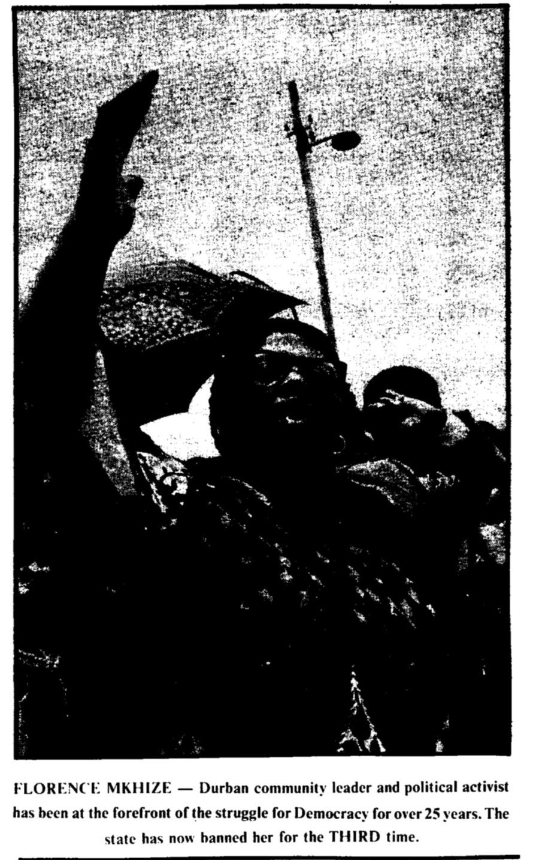
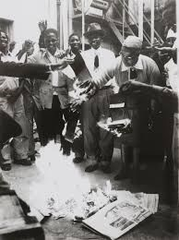
Figure 2. SASPU, “Durban activist Mkhize hit by yet another banning order.”
Figure 1. Ranjith Kally. Florence Mkhize Burning her Pass Book​. Not dated. The Evidence of Things Not Seen: Photography and Resistance, Johannesburg Art Gallery, Johannesburg, South Africa.

The ANC was banned in 1960, but FEDSAW was not. Mkhize continued to participate in the effort against apartheid despite the fact that leaders were frequently banned. On the 9th of November, 1961, Mkhize spoke on behalf of the Women's Federation at a farewell for Chief Luthuli as he left for Oslo to accept the Nobel Peace Prize.​ She was chosen as their representative due to her importance in the anti-apartheid movement. In 1962, after Mkhize was banned while returning from a conference in Port Elizabeth, Adelaide Tamb​o reached out to Martin Luther King Jr., asking him to use his influence to help draw global attention to their situation. He did not meet this request, and remained publicly silent on the matter.
Mkhize was incarcerated under the Suppression of Communism Act in 1963 and then once more in 1965, when she was held in Pietermaritzburg prison. She appeared in the
Durban Regional Court on 23 November 1967 after being accused of contravening the Suppression of Communism Act by speaking at a funeral service for Chief Luthuli. She was detained for several months before being allowed to appear in court, and served 90 days in prison. In 1968 she was banned once again along with several other prominent leaders in a wave of bannings.
Once banned, the ANC and SACP organized underground, and Mkhize continued her work against apartheid. In the 1970s, Mkhize devoted herself to the Release Mandela Campaign, hoping to free him and allow him to return to his work. In the 1980s, Mkhize flew to Amsterdam to raise money with the goal of building schools in black townships, and these efforts resulted in the founding of Phambili High School. These schools were meant for the children who were turned away from other schools due to their parents' political activities. On 25 September 1980, Mkhize spoke to the students of the University of Witwatersrand regarding her perspective on the President’s Counci​l,​ which was created to advise the president, and Inkatha,​ an organization that claimed to be working towards non-racial democracy but cooperated with the apartheid policies of Bantu Authorities, claiming that this organization would not lead to freedom. She argued that the purpose of the President’s Council was not to encourage equality, but to maintain the status quo. Despite the dangers of speaking out, she had no fear of voicing her opinion regarding Inkatha because she believed the organization was wrong. She condemned the United States for inaction, and states that their true leader, Mandel​a,​ is currently imprisoned on Robben Island. She claims to be speaking on the behalf of several​ significant leaders, including Steve Bik​o,​ in support of Mandela and in opposition to Inkatha. In 1981 she was banned again, preventing her from supporting her family as the sole breadwinner with her work as a seamstress, as her husband was unable to work due to health issues. This banning did not prevent her from working towards change, and in 1983 she helped found the United Democratic Front (UDF). This organization was non-aligned, and quickly became the largest anti-apartheid organization.
Mkhize participated in political activism within her community of Lamontville as well. Lamontville is known for both its problems and the mobilization of its residents to counteract these issues. Due to a housing crisis and an increase in the price of rent, Lamontville experienced significant urban violence in 1983. Local leader Harrison Msize Dube formed the Joint Rent Action Committee (JORAC) to address the living conditions. After Dube’s murder local violence skyrocketed, resulting in increased police patrolling and as a result, more police brutality. On 16 April, armed soldiers blocked all points of access to the Lamontville township, raided the homes of anti-apartheid activists, searched all who tried to enter or exit, and performed searches of all houses. Police vaulted Mkhize’s gate to search her house, and confiscated documents regarding a schooling crisis that were in her possession. The conflict in Lamontville quickly escalated. Much like JORAC, Inkatha represented the bourgeoise. However, Inkatha lacked the support of the youth and radical South Africans, who disliked Inkatha’s participation in the Bantustan system. JORAC affiliated with the UDF and thus became involved in the conflict with Inkatha. Inkatha mobilized troops in Lamontville resulting in violence between their troops and the local youth.
Florence Mkhize served as a unifying force in Lamontville as well as South Africa as a whole. Her leadership was recognized both nationally and locally after apartheid, and in 1996 she was elected Lamontville ward councilor in local government elections by a majority. Mkhize’s incredible life of activism received well-deserved recognition. In 1998, she received the Bravery Award from the ANC Women's League, and in 1999 she was awarded a Military Gold Medal by Nelson Mandela at an Umkhonto we Sizw​e Military Veterans Conference.​ As a form of recognition, her name was given to city center municipal offices in her honor. She passed away on 10 July 1999.

Works Cited:
African National Congress (South Africa), (Lusaka, Zambia). Mayibuye, Vol. 1, No. 10, 1967​, 1967. doi:10.2307/al.sff.document.1609.9303.0001.010.dec1967. (Accessed 7 April 2020).
"An Ode to Valuable Contribution of Women in Society". The Independent on Saturday​ (South Africa). August 23, 2014.
Chance, Kerry Ryan. "Sacrifice After Mandela: Liberalism and Liberation Among South Africa's First Post-apartheid Generation." Anthropological Quarterly​ 88, no. 4 (2015): 857-79. www.jstor.org/stable/43955495.​ (Accessed April 7, 2020).
Degregory, Crystal A., and Lewis V. Baldwin. "Sexism in the World House: Women and the Global Vision of Martin Luther King Jr." In Reclaiming the Great World House: The Global Vision of Martin Luther King Jr.​, edited by Baldwin Lewis V. and Crawford Vicki L., by Franklin Robert M., 107-30. Athens: University of Georgia Press, 2019. www.jstor.org/stable/j.ctvfxv9j2.10. (Accessed April 7, 2020). ​
“Durban Activist Mkhize Hit by Yet Another Banning Order.” SASPU National, Vol. 2, No. 2​, 1981. doi:10.2307/al.sff.document.1680.6867.002.002.mar1981. (Accessed 7 April 2020).
“Fed Woman Rips Gatsha: ‘We don't need outside help, we can help ourselves’.” SASPU​ National, Vol. 1, No. 3​, 1980. doi:10.2307/al.sff.document.1680.6867.001.001.oct1980. (Accessed April 7 2020).
“Florence Mkhize.” Ethekwini Municipality. Accessed April 30, 2020. http://www.durban.gov.za/City_Government/street_renaming/Biographies/Pages/Florence-Mkhize.aspx.
Gillwald, Alice. “Ex-ANC member slams Council, Inkatha.” Rand Daily Mail​, September 26, 1980.
Kally, Ranjith. Florence Mkhize burning her pass book​​. Not dated. The Evidence of Things Not Seen: Photography and Resistance, Johannesburg Art Gallery, Johannesburg, South Africa.
Maylam, P., & Edwards, I. (1996). The people's city: African life in twentieth-century Durban. Pietermaritzburg, SA: University of Natal Press.
Mkhize, Florence. Interview by Couzens, T. and Van Gylswyk, A. Tape recording. Durban, December 12, 1980. Institute for Advanced Social Research, Records, 1980s-1990s. Archive From Wits Historical Papers.
Nkondo, G.M., Buthelezi, Manas, Gwala, Mafika Pascal, and Thoahlane, Thoahlane. Black Renaissance: Papers from the Black Renaissance Convention, December 1974​. Ravan Press, 1974. doi:10.2307/al.sff.document.boo19741200.032.009.289. (Accessed April 7, 2020).
“No Longer Banned.” Rand Daily Mail, ​ ​August 4, 1973.
Nozizwe Madlala-Routledge. "What Price for Freedom? Testimony and the Natal Organisation of Women." Agenda: Empowering Women for Gender Equity​​, no. 34 (1997): 62-70. doi:10.2307/4066243. (Accessed April 6, 2020).
Sheldon, Kathleen. "Liberation Struggles and Politics from the 1950s to the 1970s." In African​Women: Early History to the 21st Century​, 169-206. Bloomington, Indiana: Indiana University Press, 2017. www.jstor.org/stable/j.ctt2005v2z.1​1.​ (Accessed April 7, 2020).
"South Africa Politics; Florence Mkhize - A Stalwart Is No More." Africa News​ ​, July 12, 1999.
“South Africa: Security Forces Seal Off Black Township.” IPS-Inter Press Service​​, April 16, 1986.
Torr, L. (1996). Lamontville. In P. Maylam & I. Edwards (Authors), The people's city: African life in twentieth-century Durban (pp. 245-273). Portsmouth, NH, NH: Heinemann.
Vahed, Goolam. "Monty … Meets Gandhi … Meets Mandela: The Dilemma of Non-violent Resisters in South Africa, 1940–60." In South Africa and India: Shaping the Global​ South​, edited by Hofmeyr Isabel and Williams Michelle, 105-24. Johannesburg: Wits University Press, 2011. www.jstor.org/stable/10.18772/22011055386.1​0. (Accessed April​ 7, 2020).
“60 Iconic Women - The People behind the 1956 Women's March to Pretoria (11-20).” The Mail​ & Guardian​, August 25, 2016. https://mg.co.za/article/2016-08-25-60-iconic-women-the-people-behind-the-1956-wome ns-march-to-pretoria-11-20/. (Accessed April 7, 2020).​

​Florence Mkhize, Interview by Couzens, T. and Van Gylswyk, A. Tape recording. Durban, December 12, 1980. Institute for Advanced Social Research, Records, 1980s-1990s. Archive From Wits Historical Papers.
Mkhize, Interview by Couzens, T. and Van Gylswyk, A. Tape recording. Durban, December 12, 1980.
Mkhize, Interview by Couzens, T. and Van Gylswyk, A. Tape recording. Durban, December 12, 1980.
​“Florence Mkhize.” Ethekwini Municipality. Accessed April 30, 2020. http://www.durban.gov.za/City_Government/street_renaming/Biographies/Pages/Florence-Mkhi ze.aspx.
“60 Iconic Women - The People behind the 1956 Women's March to Pretoria (11-20).” The​ Mail & Guardian​, August 25, 2016. https://mg.co.za/article/2016-08-25-60-iconic-women-the-people-behind-the-1956-womens-marc h-to-pretoria-11-20/.​ (Accessed April 7, 2020).
​The Mail & Guardian, “60 Iconic Women.”
​“Durban activist Mkhize hit by yet another banning order.” SASPU National, Vol. 2, No. 2​​, 1981. doi:10.2307/al.sff.document.1680.6867.002.002.mar1981. (Accessed 7 April 2020).
Kathleen Sheldon, "Liberation Struggles and Politics from the 1950s to the 1970s." In African​ Women: Early History to the 21st Century​, 169-206. Bloomington, Indiana: Indiana University Press, 2017. www.jstor.org/stable/j.ctt2005v2z.1​1.​ (Accessed April 7, 2020).
​Ethekwini Municipality, “Florence Mkhize.”
​Mkhize, Interview Couzens, T. and Van Gylswyk, A.
The Mail & Guardian, “60 Iconic Women”; SASPU, “Durban activist Mkhize hit by yet another banning order.”
Mkhize, Interview by Couzens, T. and Van Gylswyk, A.
​The Mail & Guardian, “60 Iconic Women.”
Mkhize, Interview by Couzens, T. and Van Gylswyk, A.
Mkhize, Interview by Couzens, T. and Van Gylswyk, A.
​Mkhize, Interview by Couzens, T. and Van Gylswyk, A.
​SASPU, “Durban activist Mkhize hit by yet another banning order.”
​"South Africa Politics; Florence Mkhize - A Stalwart Is No More." Africa News​, July 12, 1999.
​Kerry Ryan Chance, "Sacrifice After Mandela: Liberalism and Liberation Among South Africa's First Post-apartheid Generation." Anthropological Quarterly​ 88, no. 4 (2015): 857-79. www.jstor.org/stable/43955495.​ (Accessed April 7, 2020).
Paul Maylam & Iain Edwards. (1996). The people's city: African life in twentieth-century Durban. Pietermaritzburg, SA: University of Natal Press.
Maylam & Edwards. (1996). The people's city: African life in twentieth-century Durban.
Mkhize, Interview by Couzens, T. and Van Gylswyk, A.
Mkhize, Interview by Couzens, T. and Van Gylswyk, A.
​G.M. Nkondo, Buthelezi, Manas, Gwala, Mafika Pascal, and Thoahlane, Thoahlane. Black​ Renaissance: Papers from the Black Renaissance Convention, December 1974​. Ravan Press, 1974.
​Mkhize, Interview by Couzens, T. and Van Gylswyk, A.
​Goolam Vahed, "Monty … Meets Gandhi … Meets Mandela: The Dilemma of Non-violent Resisters in South Africa, 1940–60." In South Africa and India: Shaping the Global South​ ​, edited by Hofmeyr Isabel and Williams Michelle, 105-24. Johannesburg: Wits University Press, 2011.
SASPU, “Durban activist Mkhize hit by yet another banning order”; Crystal A. Degregory and Lewis V. Baldwin, "Sexism in the World House: Women and the Global Vision of Martin Luther King Jr." In Reclaiming the Great World House: The Global​ ​Vision of Martin Luther King Jr.​, edited by Baldwin Lewis V. and Crawford Vicki L., by Franklin Robert M., 107-30. Athens: University of Georgia Press, 2019.
Africa News, “Florence Mkhize - A Stalwart Is No More."​
African National Congress (South Africa), (Lusaka, Zambia). ​Mayibuye, Vol. 1, No. 10, 1967​, 1967.
SASPU, “Durban activist Mkhize hit by yet another banning order.” ​
SASPU, “Durban activist Mkhize hit by yet another banning order.” ​
​Ethekwini Municipality, “Florence Mkhize.”
​Alice Gillwald, “Ex-ANC member slams Council, Inkatha.” Rand Daily Mail​ ​, September 26, 1980.
Mkhize, Interview by Couzens, T. and Van Gylswyk, A.
​SASPU, “Durban activist Mkhize hit by yet another banning order.”
​Africa News, “Florence Mkhize - A Stalwart Is No More."
​The Mail & Guardian, “60 Iconic Women”; South Africa: Security Forces Seal Off Black Township.” IPS-Inter Press Service​​, April 16, 1986.
Louise Torr. (1996). Lamontville. In P. Maylam & I. Edwards (Authors), The People's City: African Life in Twentieth-Century Durban (pp. 245-273). Portsmouth, NH, NH: Heinemann. p. 265.
Torr. (1996). Lamontville. p. 266.
Torr. (1996). Lamontville. p. 267.
​IPS, “Security Forces Seal Off Black Township.”
Torr. (1996). Lamontville. p. 267.
Torr. (1996). Lamontville. p. 267.
​Africa News, “Florence Mkhize - A Stalwart Is No More."
​Africa News, “Florence Mkhize - A Stalwart Is No More."
​Africa News, “Florence Mkhize - A Stalwart Is No More."

